MultiThreading and Concrency

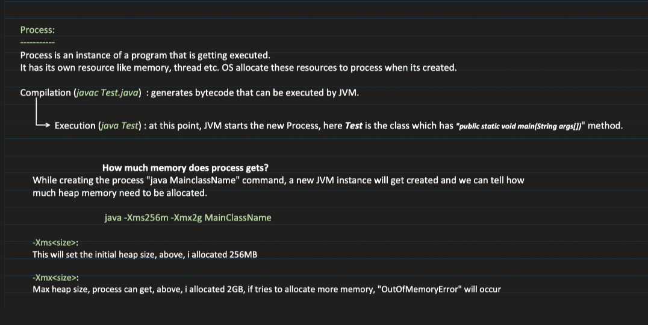

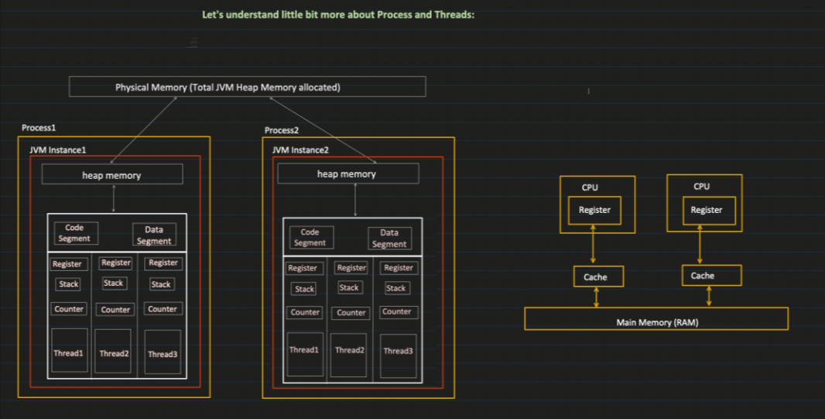

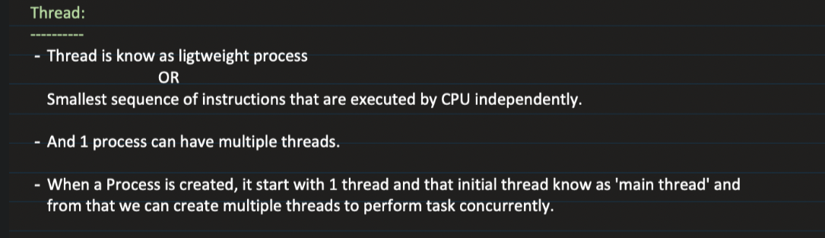

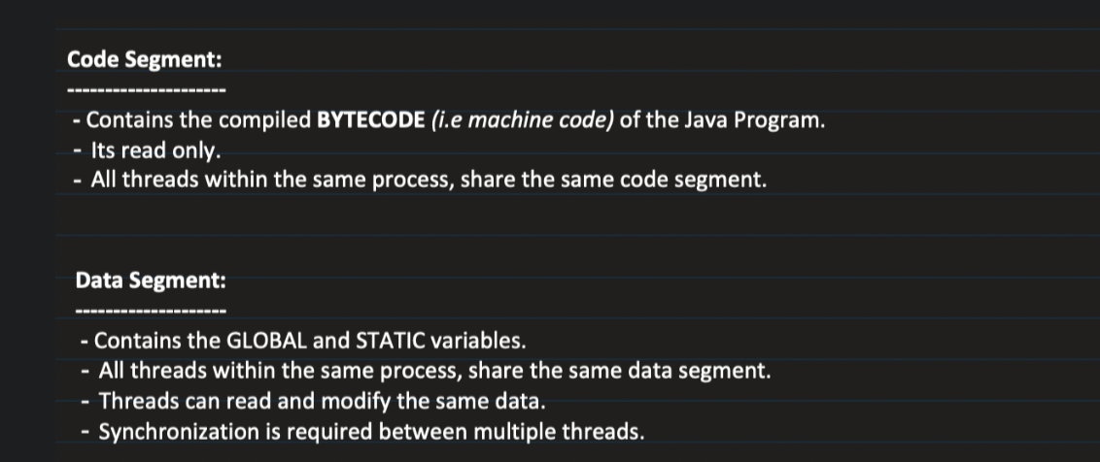

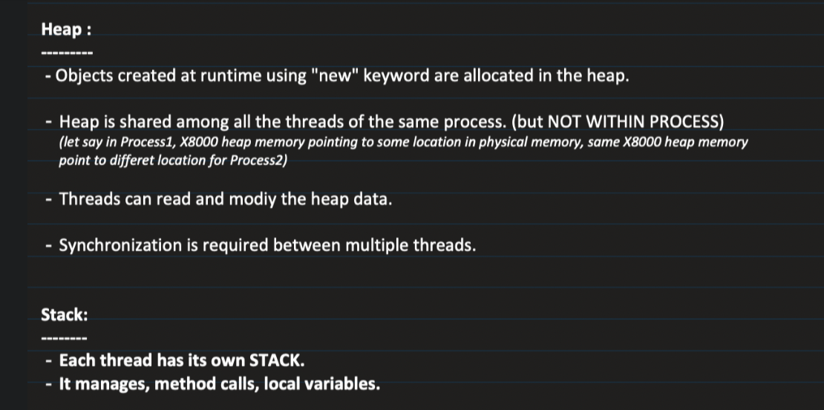

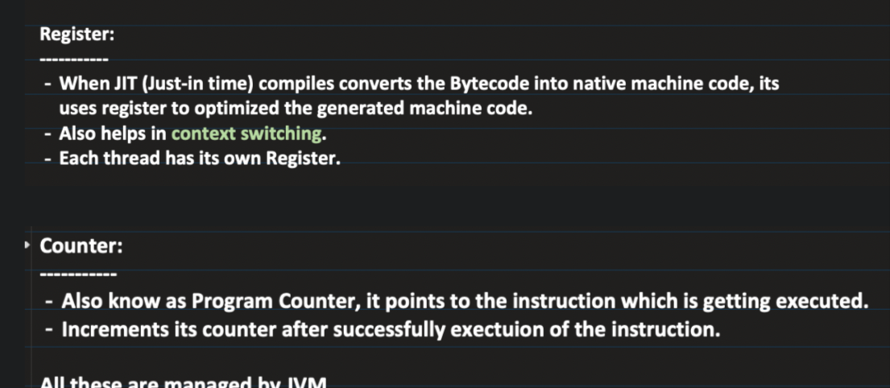

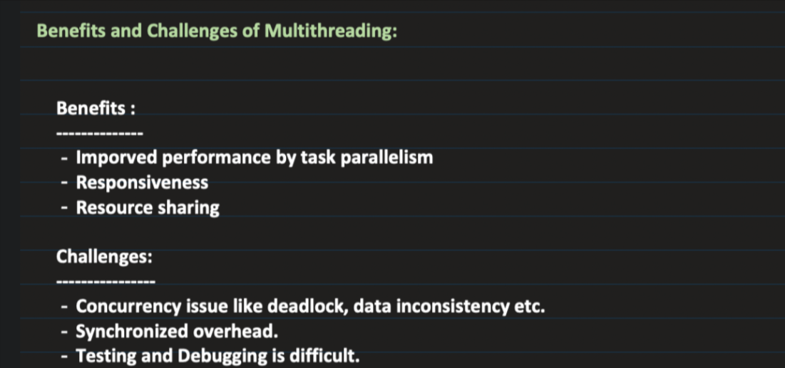

Thread Creation :

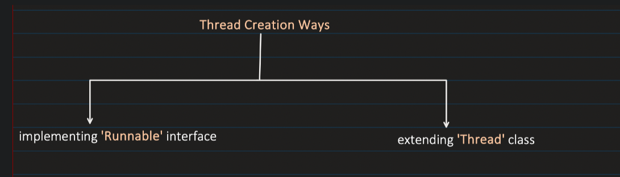

Creating a thread by using Runnable interface :(Most used Mehtod for creating a thred)

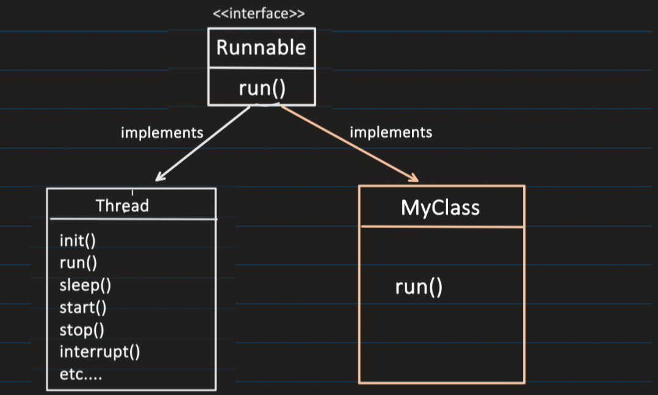

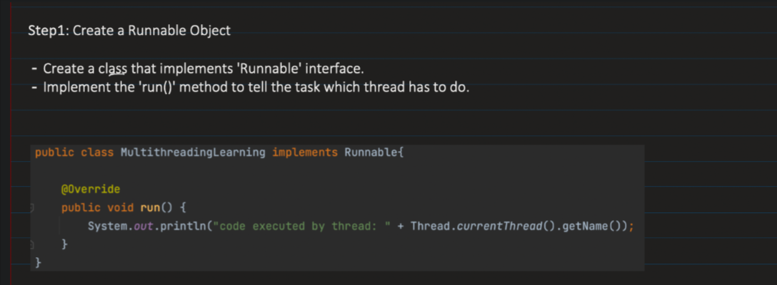

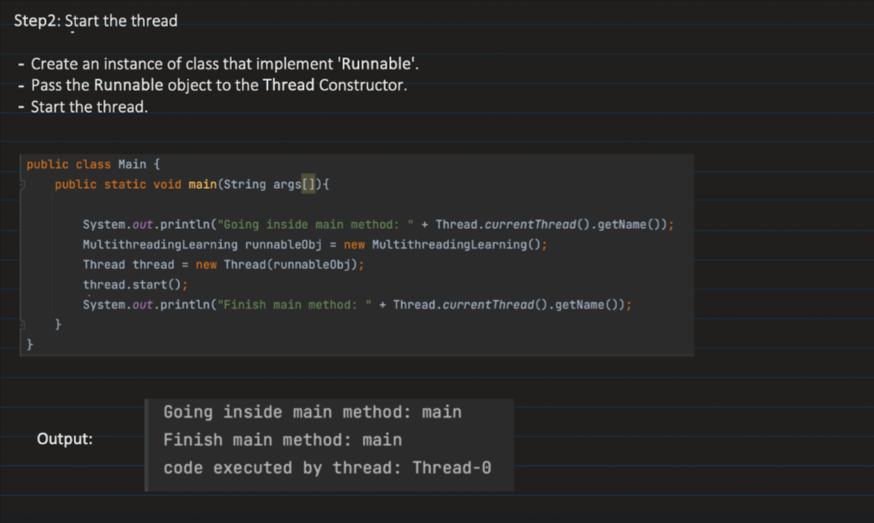

Method 2 : by extending to Thread class

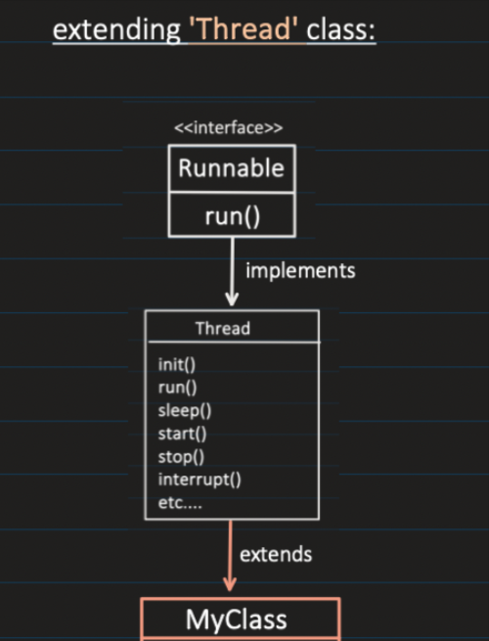

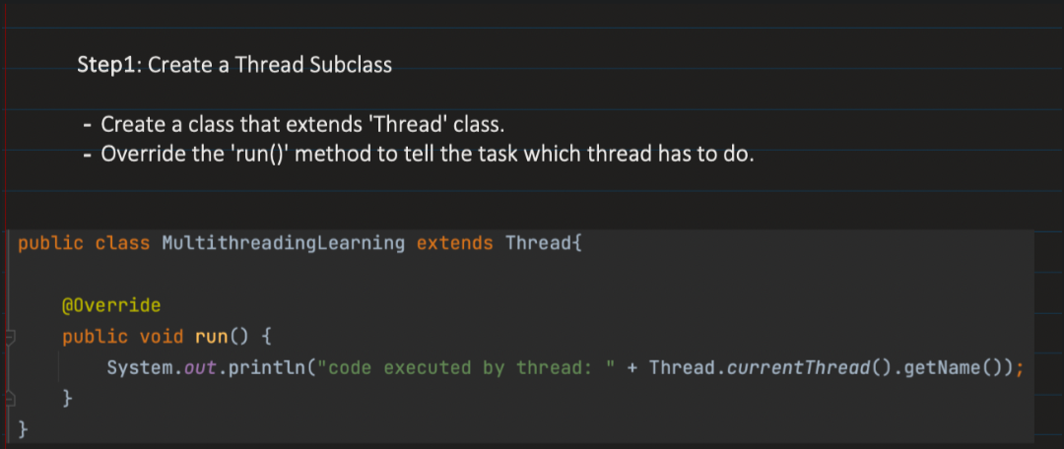

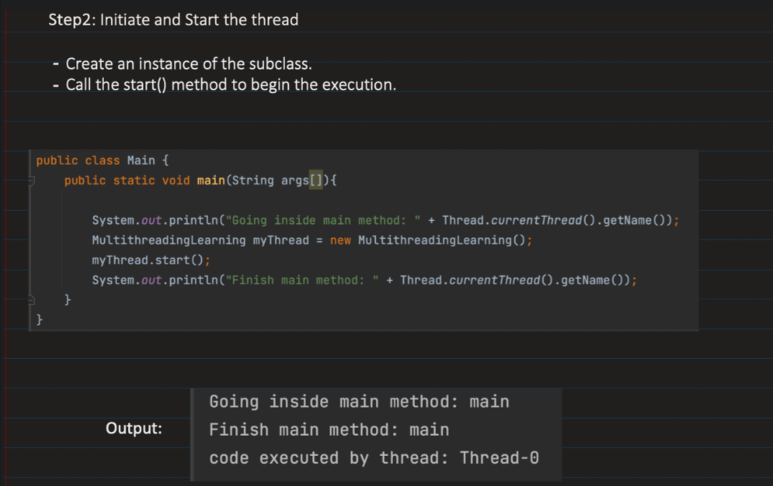

🡺Life cycle of thread

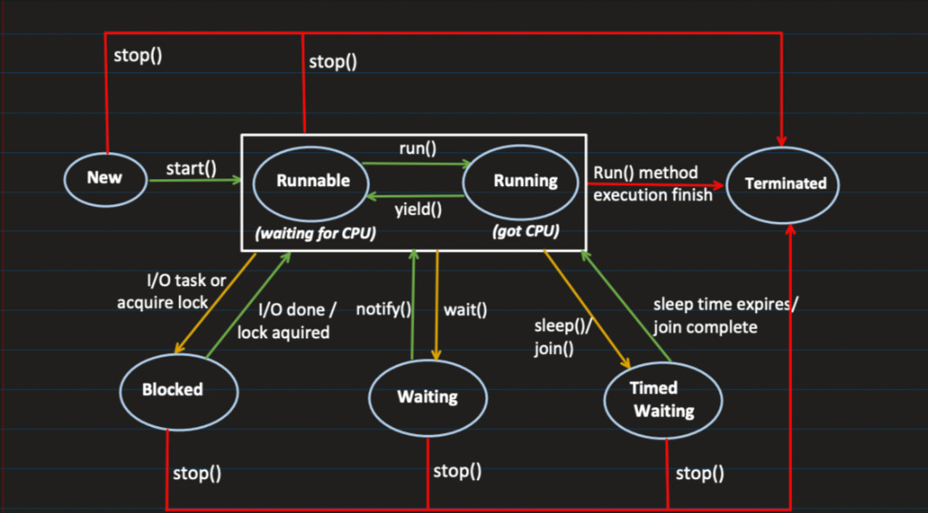

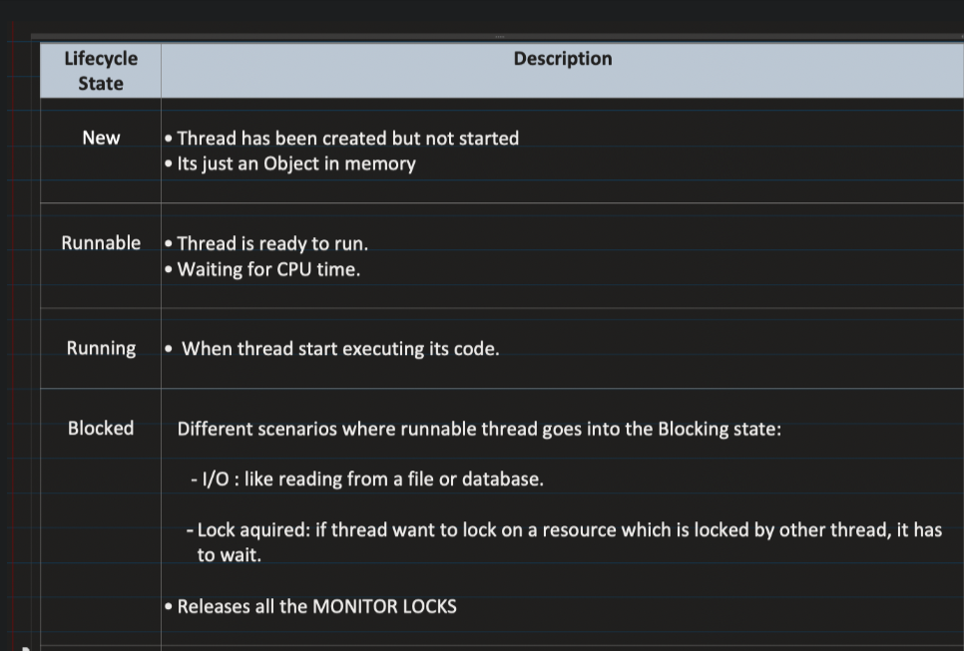

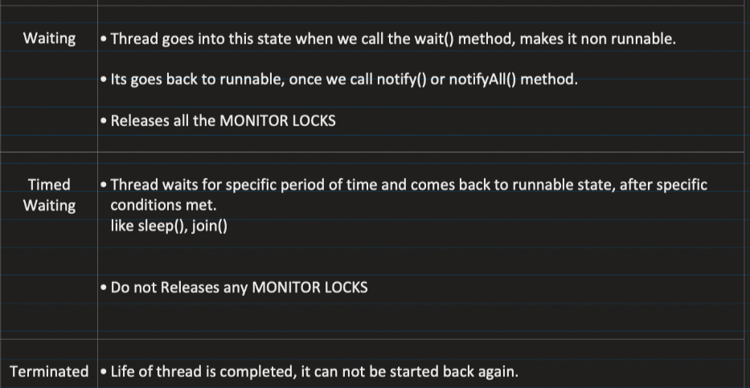

🡺Monitor Locks

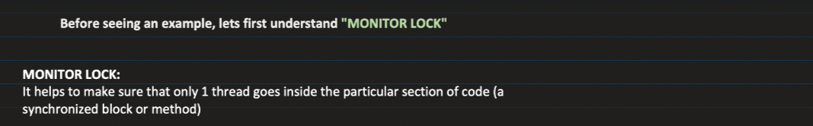

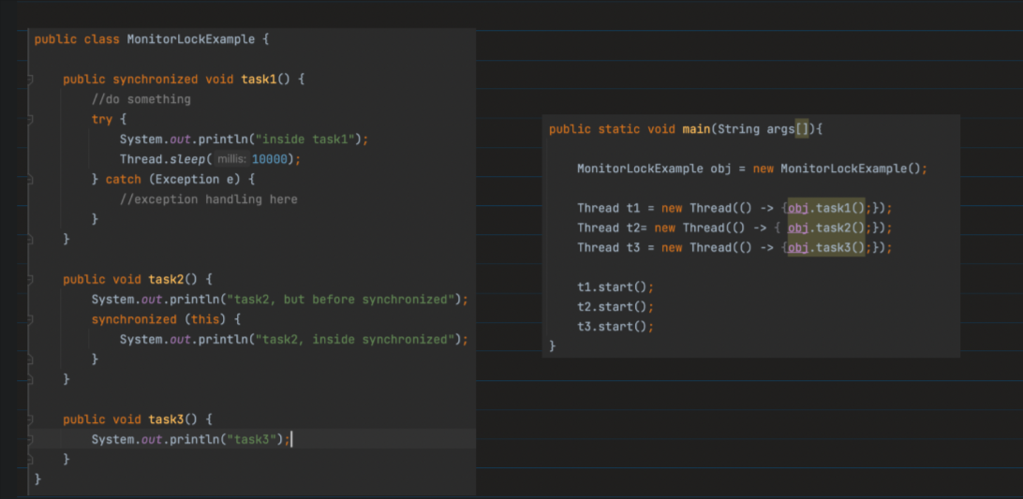

🡺Consumer Producer Problem

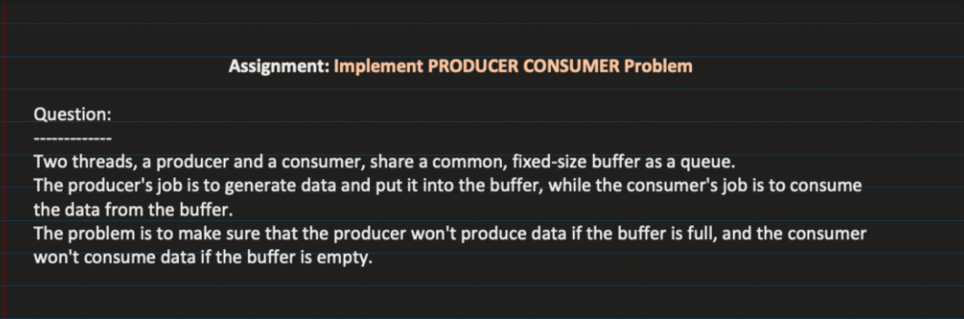

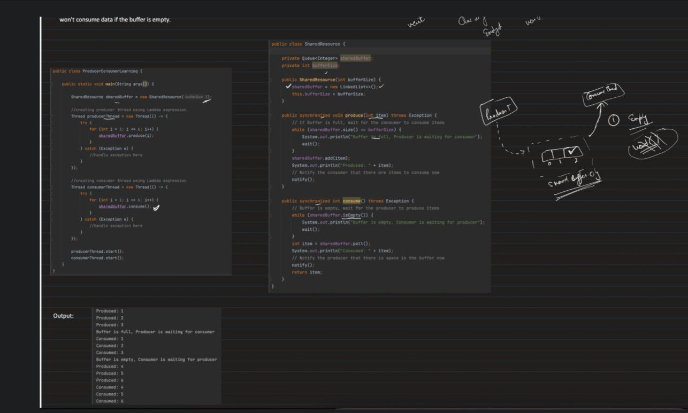

Why stop , Suspend ,and Resume method of thread is depricated ?

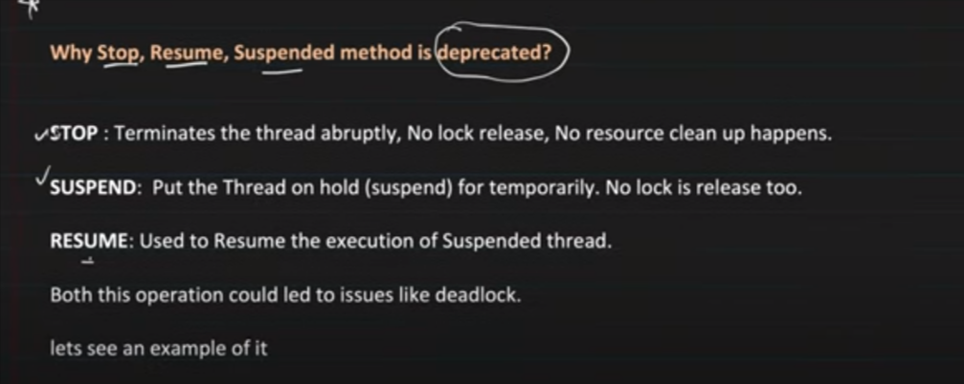

🡪virtual example

🡺Join method of thread

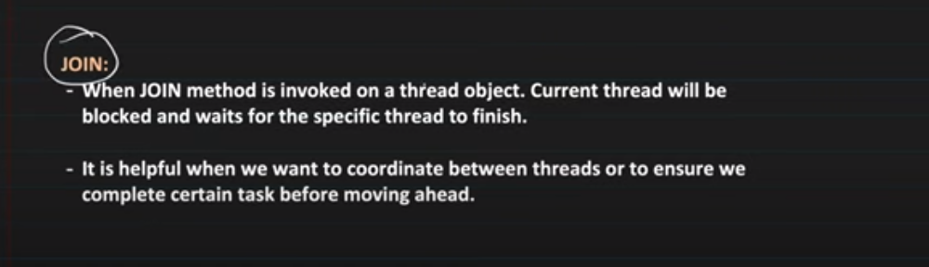

🡺Thread Priority

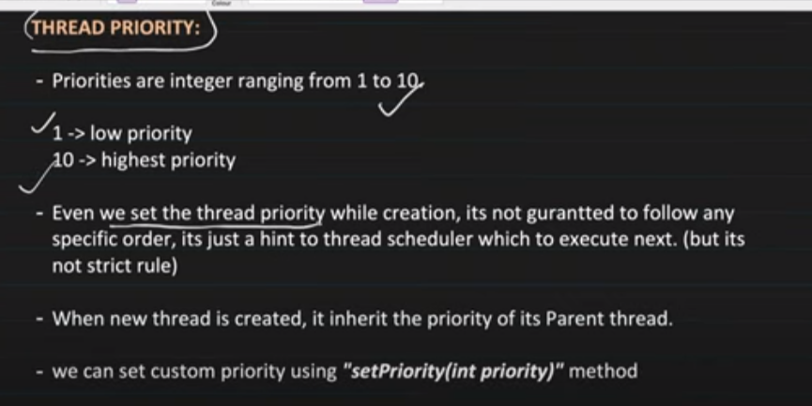

Note :we should avoid using thread priority

🡺Demon Thread

🡪we have two type of thread : i)user Thread ii)Demon thread

Demon Thread :are those thread that will going to terminate if there will be no user thread alive .

Way to set a thread as demon : t1.setDemon(true);

Ex of Demon Thread : auto save in editor , Grabge collector

**Locks and Conditons**

**Q.why we need other lock than monitor Lock ?**

**Ans: Monitor lock put lock on the different thread of same object only , not on the all the thread of all the object .**

**🡺Custom Lock**

**1.ReentrantLock**

**SharedResource.java**

import java.util.concurrent.locks.ReentrantLock;  
  
public class SharedResource {  
  
 public void consumer(ReentrantLock lock){  
  
 try {  
 lock.lock();  
 System.*out*.println("Lock is accured by thread:"+Thread.*currentThread*().getName());  
 Thread.*sleep*(5000);  
 }catch (InterruptedException e){  
 throw new RuntimeException(e.getMessage());  
 }finally {  
 System.*out*.println("Lock Relase by thread:"+Thread.*currentThread*().getName());  
 lock.unlock();  
 }  
 }  
}

**Main.java**

import java.util.concurrent.locks.ReentrantLock;  
  
//TIP To <b>Run</b> code, press <shortcut actionId="Run"/> or  
// click the <icon src="AllIcons.Actions.Execute"/> icon in the gutter.  
public class Main {  
 public static void main(String[] args) {  
  
 SharedResource sharedResource1 = new SharedResource();  
 ReentrantLock lock = new ReentrantLock();  
 Thread t1 = new Thread(() -> sharedResource1.consumer(lock));  
 SharedResource sharedResource2 = new SharedResource();  
 Thread t2 = new Thread(() -> {  
 sharedResource2.consumer(lock);  
 });  
  
 t1.start();  
 t2.start();  
 }  
}

2.ReadWriteLock

Shared Lock : Read lock

Exclucive Lock : wirte lock condition ( no other lock previously present and onely one thead can acess the resource )

Note: write lock thread will going to invocked only when there will be no ther read lock on any resource.

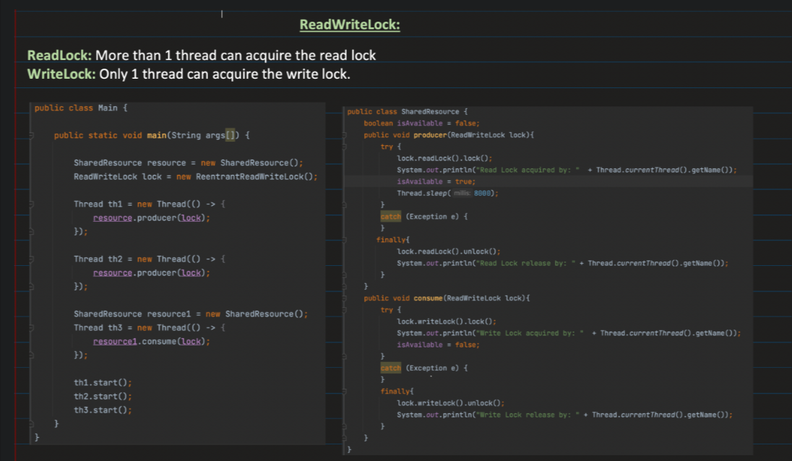

3.StampedLock

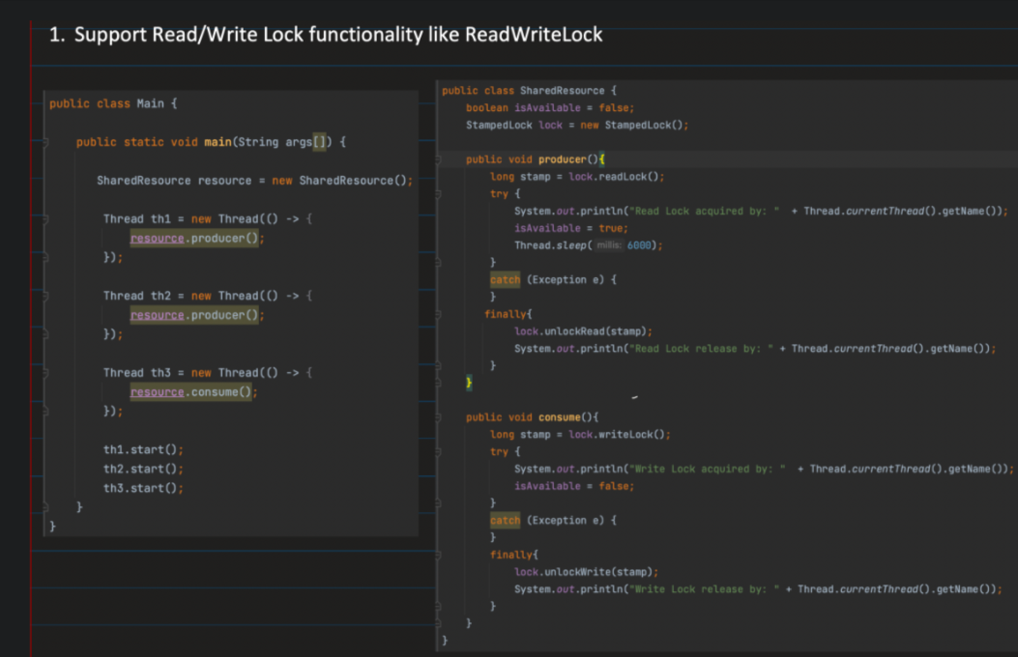

Types of lock :

i)prestimestic : it in cludes shared and excusive lock

ii)optimistic : here we donot put any lock

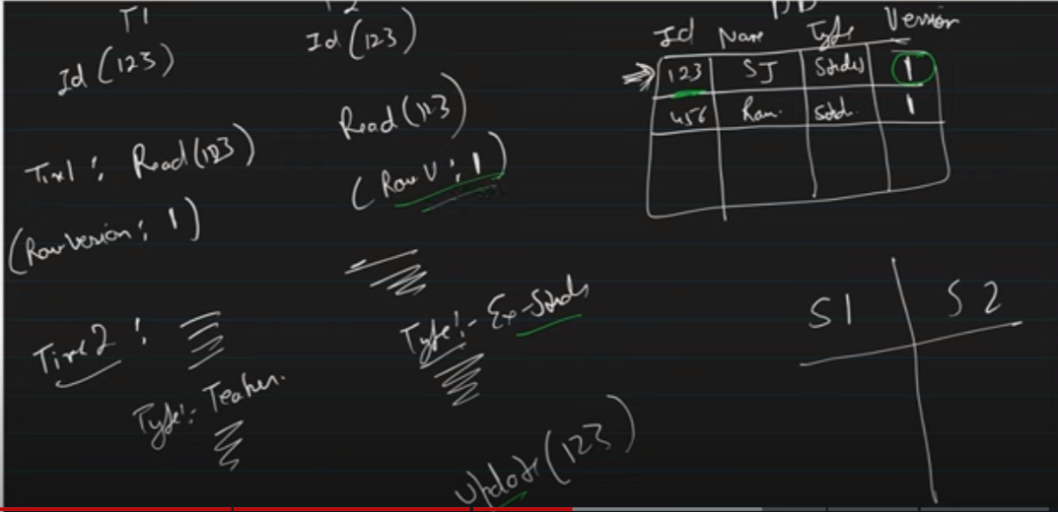

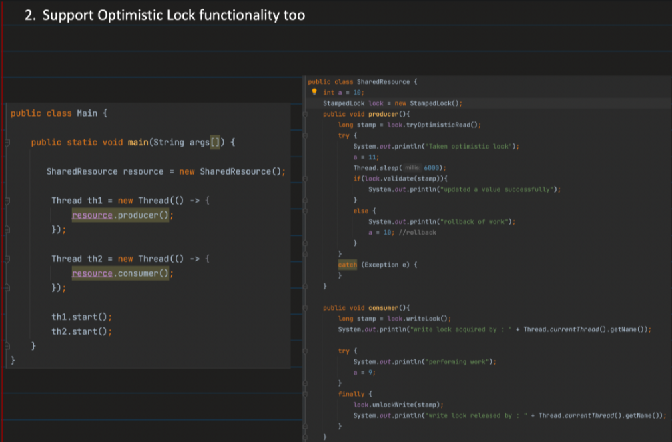

4.Semaphores lock

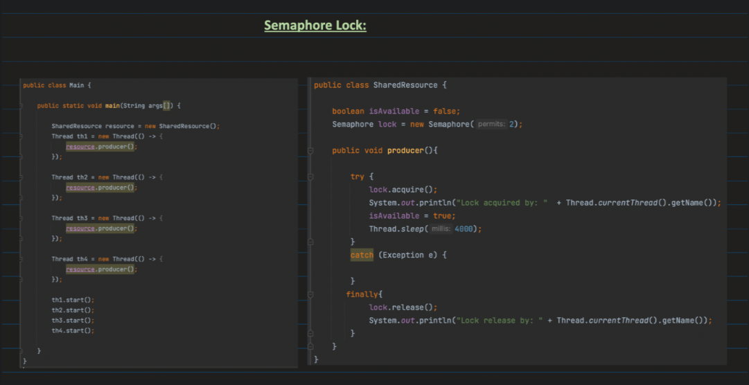

🡺How thread comminicate with each other

i)Monitor Lock comminication : throw wait() , notify()

ii)Custom lock comminication :

Condition condition=lock.newCondition(); {here lock will be any custom lock}

Method of condition :

await() , signal()

🡺Way to achive concurrency

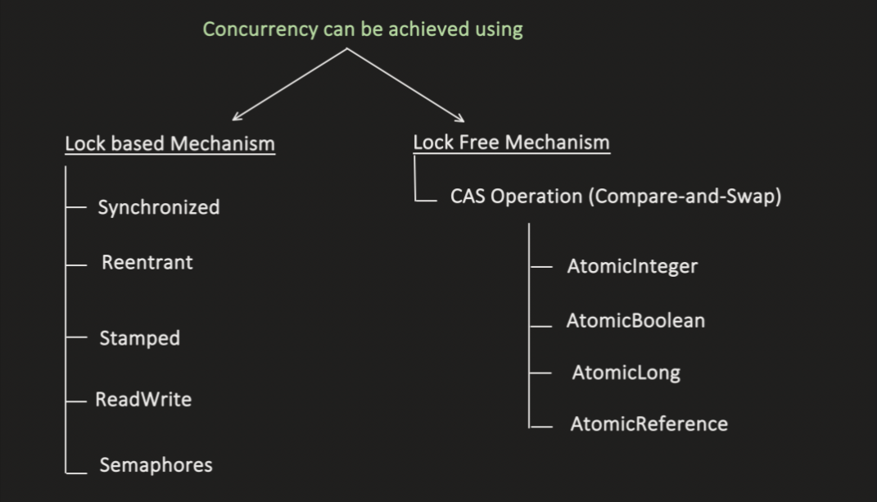

Lock Free mechanism :

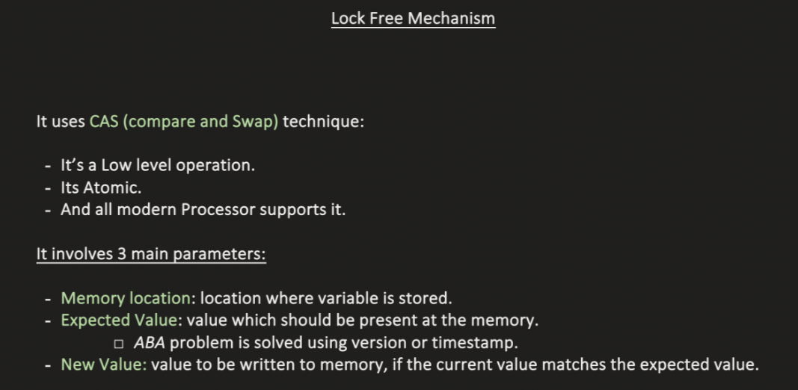

Operation digram : of CAS(compare and Swap operation)



Step 1 : load the location of variable in memory

Step2: compare the data present at that location with the excepted value

Step 3 : if data matches then update the new value . if it does’nt match then it again read the data in the same manner what we do in optemistic locking functinality

Note : it is similar to the optimestic locking fuctionality of stampLock

Lock Free operation that uses CAS operaton :

1.Atomic Varible

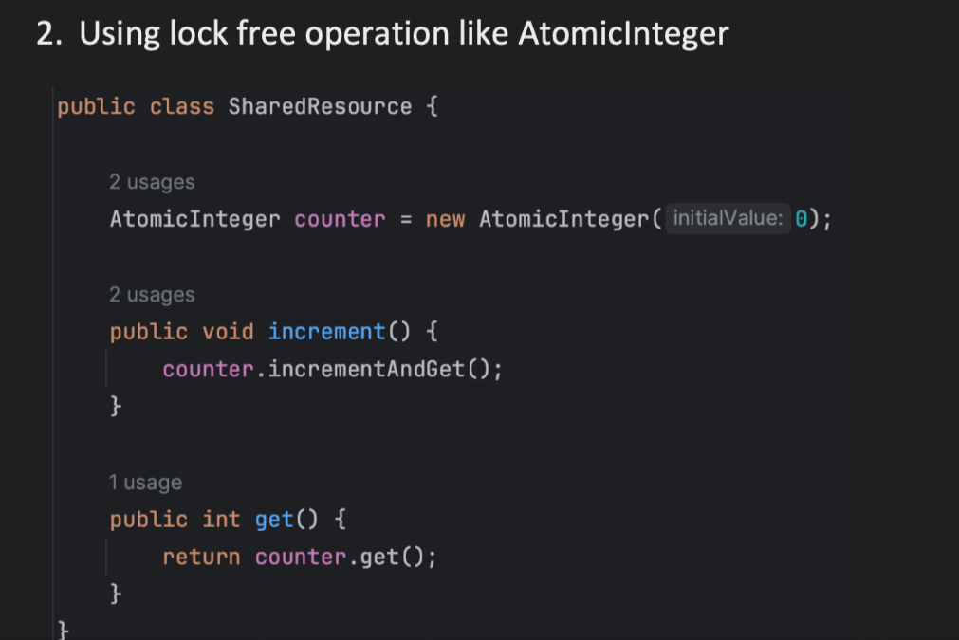

Method of Atomic variable :

i)increamentAndGet—that will going to increase the value by 1 and return the value

ii)decrementAndGet – that will going to decrease the value by 1 and return the value

iii)addAndGet(int value) – it will going to add that value to the atomic variable

iv)get()

v)getAndIncrement,getAndDecrement,getAndAdd

🡺Use Case for Atomic

i)Read ii)Modify iii)update if these three requirement is there then we can use atomic

🡺Volatile

--with the use of volatile what it does is it will going to read and update the data directly into the main memrory it will not going to intract with the cache that present in the cpu core to get data consistency

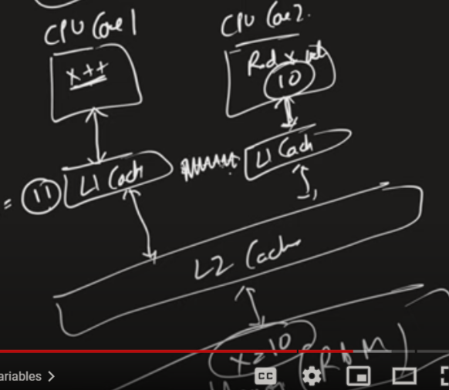

Concrent Collection :

